**Forest Chump and the Trees**

**Understanding Maintenance Caused Accidents**

**With Multiple Mixed Metaphorical Entendres**

**By L. Pete Kelley**

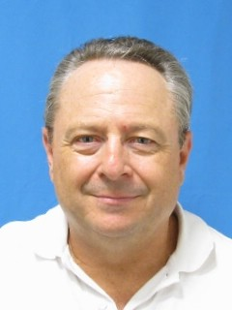

*L. Pete Kelley (MO4115) who wrote this paper independent of his employer is an FAA Aviation Safety Inspector for Airworthiness. He previously has been Manager of Regulatory Compliance, Human Factors Analyst/Researcher and Manager of Maintenance Training for America West Airlines and was an Assistant Professor for Embry-Riddle Aeronautical University, Prescott, Arizona, teaching Aviation Maintenance Management, Aviation History and Regulations, Airline Management, Air Transportation Economics, Transportation Principles and Human Resource Management. He has worked as an aircraft mechanic in general aviation and for Air North (an Allegheny Airlines commuter), Eastern Airlines, Empire Airlines (not the current one) and America West Airlines. He holds a BS in Aviation Maintenance Management and an MBA-Aviation from Embry-Riddle Aeronautical University.*

**The views expressed in this paper do not necessarily represent the views of the United States (U.S), the U.S. Department of Transportation (DOT), the Federal Aviation Administration, or any other Federal agency.**

**Accident Causation Theories and Maintenance**

Twenty five years ago while in an airline’s Human Factor’s Department, before airlines were required to have a Director of Safety, I was helping to develop a proposal for the creation of a Safety Department. I reviewed the literature on human error, complex system accidents and accident causation theories. Two years ago I undertook the same review as foundational preparation for writing a paper concerning investigating maintenance’s role in aircraft accidents. I observed two changes: [1]

1. Complexity had taken front stage with human error moving to back stage;
2. Investigating how work is actually done is being directed toward front stage and accident investigation is being nudged toward back stage.

The collage in figure 1 below presents labels and symbols of error and accident theory models. Reflect on how you understand the causes of accidents. Models are accepted when they help us understand something, but by their very nature, they are also incomplete and to some degree inaccurate. They also can become an impediment to further or better understanding of a subject. According to psychologist Daniel Kahneman, theory-induced blindness can happen because “once you have accepted a theory and used it as a tool in your thinking, it is extraordinarily difficult to notice its flaws.” [2] Theories and models help our understanding, but in reality, they may also function as paradigm shift blockers or accurate interpretation uptake inhibitors, if you will. [3]

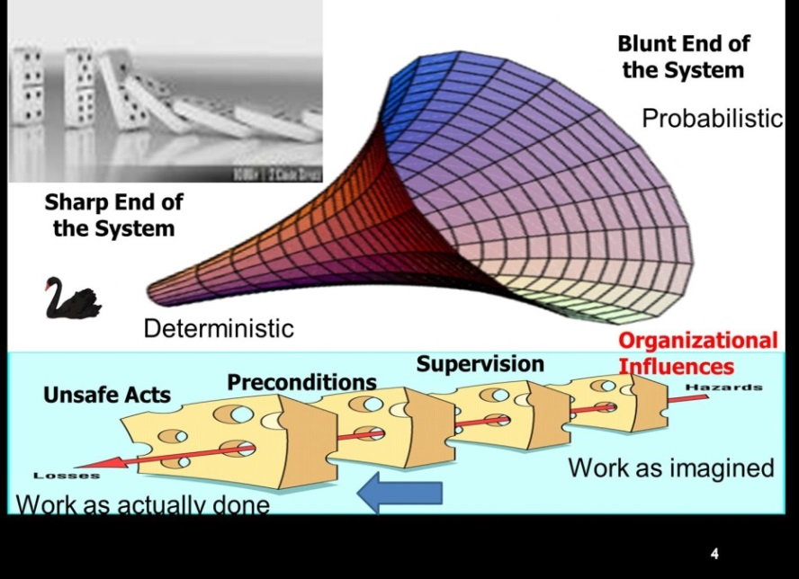

**Figure 1**

The newest theories indicate that investigating how work is actually done is more efficacious than investigating why particular accidents happened. These theories are based upon the belief that the people on the pointy end of the system are frequently improvising to make the system work well and because the system is too dynamic, complex and sometimes chaos-ish. [1 & 4] I believe that for maintenance, the older approach of thorough investigation of accidents still has much to offer. For maintenance, investigations can and should really make a difference! But, when investigating maintenance caused accidents, focusing on how maintenance is actually performed is going to be the most important part.

The justification for investigating, either before and/or after accidents, to find improvements for the level of safety in aviation, is nearly the same as it has always been. In figure 2 below we see that fitting a line to estimate what a running (moving/rolling) average of deaths per year has been, only shows a modest downward trended down in the past 55 years. The accident rate dropped precipitously in the 1960’s and has remained very low, but the actual number of casualties has not. 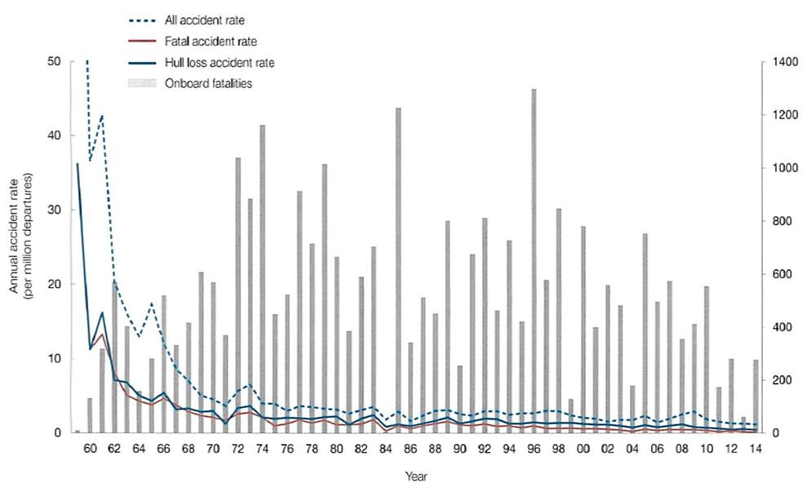

**Figure 2** [5]

James Reason presented a paper in 1997 at an International Aviation Safety Conference in Rotterdam, Netherlands with the following title and quote: [5]

* “Maintenance-related Errors: The Biggest Threat to Aviation Safety After Gravity?”
* “Maintenance related errors rather than fallibility on the flight deck constitute the largest human factors problem”

The reason that maintenance remains an area in which significant improvements can be made is because very little has changed in how maintenance has been done in the last 50 years. Compare this to the vast improvements in technology and pilot training and procedures in the past 50 years.

Returning to traditional accident causation theory, the oldest model is H.W. Heinrich’s Triangle/Pyramid depicting 300-29-1 ratios concerning the severity of employee injuries. [6] The “**standard theory**” has been that accidents have multiple causes that combine unexpectedly, with some aspects usually surprising the operator. In figure 3 below, I have combined Heinrich’s concept with the belief that on average there are 3 to 4 preventable events for each accident. [7] I have made the generalization that if there is an average of 4 causes for an accident, then there would be an average of 3 for an incident and an average of two for an occurrence. [1]

In figure 3 below, the number 4 at the top of the triangle depicts an accident, which averages 4 causal factors. If there were only three causal factors on average, the mishap would be an incident depicted by the 3 in the middle of the triangle. And if the event had only two causal factors in this generalized theory, it would be only an occurrence. Using Heinrich’s Law we should expect there to be 29 times more incidents than accidents and 300 times more occurrences than accidents. The area below the triangle is a forest of possible causes with each letter being a tree in that forest which depicts an individual potential contributing cause.

In figure 4 below, the **standard theory** is extended to include the subset of maintenance causes. In the article “Boeing Introduces MEDA - Maintenance Error Decision Aid,” the idea was introduced that each maintenance mishap has on average, 3.2 contributing factors. [8]

**Extension of Heinrich’s Yield Concept Applied to Causes**

**Forest Of Potential Casual Factors Trees**

**awrbctskfudpsnzxlpqavjssmxvasidleeual**

Figure 3

**Figure 3**

The small triangle in the lower right corner of figure 4 represents the case where maintenance is a causal factor in an accident and the other 3 small triangles represent the other 3 factors. This maintenance contributing factor had its own causes (a, b, and c). If any one of these 3 factors in maintenance were missing then the maintenance contributing factor would not exist and the accident would not happen.

**Extension Theory to Maintenance**



**Maintenance**

**C**

**B**

**A**

**Figure 4**

**Maintenance performed properly prevents accidents!** An example of when the maintenance performed unintentionally did not ensure airworthiness and where proper maintenance could have prevented an accident which had many other non-maintenance contributing causes, was Delta Flight 1141 on August 31, 1988. The aural takeoff warning horn test performed during an A-2 check 20 days before the accident found a discrepancy that the horn was “weak and **intermittent** when throttles pushed forward.” No fault isolation was performed. The horn was replaced and tested **once**. After the accident, on-scene and subsequent activations confirmed intermittent functioning of the takeoff warning micro switch either because of corrosion type contamination of switch contacts or misactuation of the switch because of the actuator button slipping off the switch plunger. [9]

**But, is it normal in maintenance to properly follow all procedures?**  The best insight on how maintenance is actually performed comes from a survey of maintenance technicians conducted by Alan Hobbs at the Australian Transportation Safety Bureau. Concerning short cuts around required procedures most respondents (69%) considered that it was sometimes necessary to ‘bend the rules’ to get the job done. While 38% of respondents believed that their management discouraged shortcuts, the remaining respondents considered that management either did not know about shortcuts, or tolerated them. See the following more specific survey responses chosen because of their likelihood of catastrophic results. Observe that only a few are unintentional: [10]

15% Intentionally over-torqued a bolt to make it fit

30% Rigged a system without the proper rigging boards or tooling

30% Rigged system incorrectly because of unclear or misleading documentation

30% Signed off a task before it had been completed

30% Did not perform required functional check or engine run because of a lack of time

30% Did not use maintenance manual or other documentation on an unfamiliar job

55% Signed a job on behalf of someone else without checking it

55% Did an unfamiliar job, when uncertain whether it was being done correctly

70% Had difficulty with a task because of not understanding how the system worked

75% Disconnected something to make a job easier & not documenting it

75% Misled by turn over having wrong information about stage of job progress

85% Did not document a small job

90% Completed a job without the correct tool or equipment

90% Did not use maintenance manual or other documentation on a familiar job

90% Had been misled by confusing documentation

I believe that Hobb’s survey provides evidence that the **failure to follow procedures is normative in aircraft maintenance. A “normalized deviation!”** to use a phrase from Diane Vaughan’s book, The Challenger Launch Decision: Risky Technology, Culture, and Deviance at NASA. [11]

Further evidence of this can be drawn from accident reports where maintenance was the sole cause. The **reports find failure to follow procedures, but never question its existence beyond the location where the maintenance was performed**. Figure 5 below list 7 fatal accidents caused by failures in maintenance.

Figure 5

**When the Standard Theory Did Not Apply**

Flight 9446 Colgan Air August 26, 2003

Flight 5481 Air Midwest January 6, 2003

Flight 261 Alaska Airlines January 31, 2000

Flight 592 ValueJet Airlines May 11, 1996

Flight 1288 Delta Air Lines July 6, 1996

Flight 2574 Continental Express September 11, 1991

Flight 5390 British Airways June 10, 1990

**In these events, maintenance was the dominate factor with the same two failures in maintenance**

**Figure 5**

In the accidents listed in figure 5, the **standard theory** of multiple causes did not necessarily apply. To the extent that it did apply, it involved multiple failures to follow procedures in maintenance. Because they were potentiality catastrophic, in each of the 7 accidents, the regulatory intent for Required Inspection Items failed by definition. The US regulatory definitions are as follows:

*14 CFR section 121.369 (b)(2) requires air carriers develop a “designation of the items of maintenance and alteration that must be inspected (required inspections), including at least those that could result in a failure, malfunction, or defect* ***endangering the safe operation of the aircraft, if not performed properly* [like if aircraft maintenance manual procedures are not followed]** *or if improper parts or materials are used.”*

*14 CFR section 121.371 (a): “ No person may use any person to perform required inspections* ***unless the person performing the inspection is*** *appropriately certificated****, properly trained,*** *qualified, and authorized to do so.”*

The following cursory review of each accident will demonstrate the failure to follow procedures and illustrate for each why the intent of the RII requirements were not met. For a more thorough review of each see working paper “General and Specific Realities of Aircraft Maintenance” [12]

**August 26, 2003 - Colgan Air - Flight 9446 - N240CJ BE-1900D [13 & 14]**

In this accident, during the first flight after maintenance, a flight to position the aircraft for a revenue flight, the elevator trim traveled to the full nose-down position shortly after takeoff. The control column forces subsequently increased to 250 pounds, and the flightcrew was unable to maintain control of the airplane. Maintenance had just replaced an elevator trim cable during which the replacement cable was installed such that control was reversed. The flightcrew had reported what they thought was a runaway trim and manually selected nose-up trim, which created a nose down input to the trim tab.

**The procedures the technicians failed to follow** included skipping the step in the manufacturer's maintenance manual (AMM) to use a lead wire to assist with cable orientation and they did not perform an adequate functional check. Additionally, they failed to perform a function check, which was part of the RII which would have detected the reverse control of the elevator trim system.

This **more subtle failure to follow procedures** was that the Minimum Equipment List (MEL) authorization was used outside of its regulatory intent as a work around to release the aircraft thus skipping another step in the AMM which would have caught the reversed trim control. The Elevator Trim Tab Sensor check for the Flight Data Recorder (FDR) was not accomplished. Instead, the FDR was deferred on MEL. The FDR Elevator Trim Tab sensor check would have identified the reversed Elevator Trim Tab controls.

**January 6, 2003 – Air Midwest - Flight 5481 - N 233YV - BE-1900D [15]**

In this accident, there was a loss of pitch control during takeoff resulting from the incorrect rigging of the elevator control system, compounded by the airplane’s center of gravity being substantially aft of the certified aft limit. The accident airplane’s elevator control system was incorrectly rigged limiting the airplane’s elevator travel to about one-half of what was specified by the airplane manufacturer.

**The failure to follow procedures was** that some, but not all, of the steps of the elevator control system rigging procedure were accomplished when scheduled inspection identified the cable tension as being too low. The AMM required that the entire elevator control system rigging procedure be performed whenever cable tension adjustments were made, not just the cable tensioning steps which were performed by the technician. His cable tensioning brought the elevator system out of rig.

**The additional failure to follow procedures** in this case started with the failure to follow Air Midwest’s General Maintenance Manual (GMM) procedure concerning who is authorized to decide whether a specific step of the maintenance manual can be skipped. Rather than whomever the GMM authorized to make that decision to allow for skipping stems in work instructions, the aircraft maintenance technician and the quality assurance inspector who were not authorized, did so.

The independent assessment intent of the RII rule was compromised in this case because the RII Inspector was providing the supervision and OJT for the technician accomplishing the rigging task for the first time. Another step that was skipped involved the FDR pitch position potentiometer adjustment procedure. This procedure required checking FDR position readouts for eight different elevator settings. Had this procedure been followed, the first setting checked would have been 14º Aircraft Nose Down (AND) which would not have been obtainable because the rigging errors restricted elevator travel to about 7º AND.

**January 31, 2000 - Alaska Airlines - Flight 261 - N963AS - MD-83 [16]**

In this accident, there was loss of pitch control because of an in-flight failure of the horizontal stabilizer trim system jackscrew assembly’s acme (gimbal) nut threads. The thread failure was caused by excessive and accelerated wear which was caused by there being no effective lubrication on the acme screw and nut interface. In this accident, many factors in maintenance and troubleshooting in flight were identified as contributing factors.

The cause in fact however, was **the repeated failure to follow procedures** when lubricating the jack screw, combined with the **failure to follow procedures** to use the manufacture proscribed tool or its equivalent, to measure thread wear via end play. The parts that failed were dry and the lubrication (greasing) history as recorded in the maintenance records could not have been properly done. In figure 6 below, taken from the accident report, see how the passageway for the grease to travel to the jack screw is blocked by dry residue which would make any attempt to properly grease the threads unsuccessful.



**Figure 6**

Board Member John J. Goglia’s statement in the accident report concerning the effect of the blocked passageway was that “The accident aircraft was dispatched from a C-check with a jackscrew of questionable serviceability that was, in all probability, not greased. And the evidence is that it was never adequately greased again.” It was un-grease-able with the passageway blocked by the dry residue!

A safety recommendation made from this accident recommended that the jackscrew assembly lubrication procedure be made a required inspection item (RII) that must have an inspector’s signoff before the task can be considered complete.

**May 11, 1996 – ValuJet Airlines – Flight 592 - N904VJ - DC-9-32 [17]**

In this accident, an inflight fire caused the loss of control of the aircraft. The source of the fire was the chemical oxygen generators removed from another aircraft which were being shipped COMAT in the cargo compartment, which did not have safety (shipping) caps installed.

There were multiple factors within maintenance which contributed to the causal sequence, but the event that preceded them all was aircraft maintenance **technicians not following the instruction on the work card when removing the oxygen generators to “install shipping cap on firing pin.**” **The Safety Board was alarmed at the apparent willingness of mechanics to sign off on work cards indicating that the maintenance task had been completed, knowing that the required safety caps had not been installed, and at the willingness of those individuals and other maintenance personnel (including supervisors) to ignore the fact that the required safety caps had not been installed.**

The accident report stated that the work card involved did not require an RII inspector’s signature, because the task it described was not a ValuJet required inspection item (RII) task.

**July 6, 1996 – Delta Air Lines – Flight 1288 – N927DA – MD-88 [18]**

In this accident, there was an uncontained failure of the No. 1 engine front compressor front hub (fan hub) and debris from the compressor hub penetrated the fuselage killing two passengers and seriously injuring two others. The takeoff was rejected, and the airplane was stopped on the runway. The fan hub that failed had been removed from the engine 1,142 cycles prior to its failure and a fluorescent penetrant inspection (FPI), required by the life management program for the hub, was performed. Post-accident metallurgical examinations based on the striation count, indicated that at the time of this last FPI, a crack on the aft hub surface was 0.46-inch long and that this crack extended about 0.90 inch within the adjacent bolt hole. The crack was well above the minimum detection length of 0.10 inch and it should have been detectable with both a probability of detection and confidence level exceeding 95 percent if proper procedures were followed.

The Safety Board’s investigation found a number of ways in which the effectiveness of the FPI process could have been compromised **by the failure to follow procedures**. The Safety Board concluded that **one or more procedural deficiencies** in the cleaning, drying, processing, and handling of the part might have reduced or prevented the effectiveness of Delta’s FPI process in revealing the crack.

All off-wing maintenance is considered not to be RII. However, this this is not explicit in the RII regulations.

**September 11, 1991–Continental Express–Flight 2574–N33701–Embraer 120 [19]**

In this accident, there was a structural breakup resulting from the in-flight loss of the left horizontal stabilizer leading edge that the resulted in immediate severe nose-down pitchover of the airplane. The horizontal stabilizer leading edge was only partially secured because of the **failure** of Continental Express maintenance and inspection personnel **to adhere to proper** maintenance and quality assurance **procedures** for replacing the airplane’s horizontal stabilizer deicer boots.

In the analysis section of the accident report, the Maintenance Factors section begins as follows:

*“The evidence is clear that the events during the maintenance and inspection of N33701 the night before the accident were directly causal to the accident.* ***Several errors******were made by the individuals responsible for the airworthiness of the airplane****. The Safety Board believes that the reasons for the errors and the overall failure of the maintenance program are complex and are not simply related to a single failure by any single individual. Consequently, the Safety Board’s analysis of the maintenance and inspection program concentrated on the systemic reasons for the accident, as well as the specific errors made by the individuals concerned.” (emphasis added)*

In the quote, which is from the probable cause statement, the term “error” is used instead of the phrase **“failure to adhere to proper procedures.”** This was likely done to disassociate the failure to follow procedures from the intent to do wrong or cause bad outcomes, which was not involved. In the quote above, I believe that the systemic reasons for there being several errors made by the individuals responsible for the airworthiness of the airplane, is indicative of the, **normalized deviation in maintenance to not follow procedures** like Hobb’s survey indicated. **Therefore, the issue is not the complexity of the maintenance, it is the aggregate failure to follow procedures when the maintenance is performed.** [10 & 11]

The quote above can also be interpreted to show **how normative it is to fail to follow procedures is in aircraft maintenance.** What it does not capture however, is a fundamental requirement and professional practice to ensure that all maintenance is documented. In the case of this accident, a well-meaning inspector removed the screws from the upper leading edge of the other horizontal stabilizer. Because there was no documentation of the removal of these fasteners, when the work plan shifted from changing the deicer boots on both horizontal stabilizers to only changing one, the record of the maintenance could not direct the reinstallation of the screws. A turn over log in inspection did contain a note on the removal of the screws, but the record of the work performed is where that information should have resided.

**The cause in fact of this accident, the one thing that if it did not happen, all the other failures to follow procedures would not have resulted in the accident, was the undocumented maintenance of removing the screws by the inspector.**

The horizontal stabilizer leading edge removal and replacement, in this case to facilitate the changing of deicer boots, was not on the RII list. The safety issues discussed in the accident report for this accident included the **“need for reviewing regulations, policies and practices for establishing required inspection items (RIIs) with a view toward developing more specific identification of RIIs.”**

**June 10, 1990 – British Airways. – Flight BA 5390 – BAC One-Eleven [20]**

In this accident, the pilot’s windscreen blew out while the aircraft was climbing through 17,300 feet. The windscreen had been changed prior to the flight, but the securing bolts installed were one size smaller in diameter than that specified. When the cabin pressure overcame the retention of undersized bolts, the explosive decompression sucked the captain out of his seatbelt and his body was bent upwards, doubled over around the top of the aircraft. His legs were jammed forward, disconnecting the autopilot and the plane went into a dive. The co-pilot was wearing his safety harness and got the autopilot back on and descended to 11,000 feet in 2 minutes, then got the speed down to 300kmh, saving the pilot’s life. [21]

The failure to follow procedures was generalized in the accident report in the following manner, the person who changed the windscreen demonstrated **inadequate care, poor trade practices, failure to adhere to company standards and use of unsuitable equipment, which were judged symptomatic of a longer term failure by him to observe promulgated procedures.**

The windscreen change turned out to be safety critical task, which had not been identified as a ‘vital point’ (RII).

**Professionalism and The Failure to follow Procedures**

The British Airways Flight BA 5390 accident investigation involved a Behavioral Psychologist who had some very interesting comments under the header “Maintenance of Standards in Working Practices.” [20]

*“There appears to be a stark contrast between the procedures adopted to ensure that pilots adhere to standard operating procedures and to ensure that they are familiar with good working practice and those adopted for maintenance personnel…”*

*“It seems that the system operating at Birmingham” (the base where the maintenance was performed)* ***“relied entirely on the ‘professionalism’*** *of individual shift supervisors* ***to ensure that working practices were appropriate****.”*

*“Whereas it is entirely right to expect a professional approach from such individuals, the wisdom of leaving the safety of aircraft entirely to individual judgment without having any systems for maintaining consistency or for checking that high standards are met must be questionable.”*

There are some problems with the reliance on professionalism mentioned by the Behavioral Psychologist in the report quoted above when deviation from procedures is the norm. First, there is the conceptual contradiction in having a definition of professionalism that allows deviation from procedure. **The professional in these cases should be the one who refuses to proceed with the maintenance unless the procedures work and are followed completely.** Second, psychological research by Kruger and Dunning of Corrnell University indicates that this “professionalism” of making sound judgments when deviating from procedures cannot be trusted because: [22]

***''Ignorance more frequently begets confidence than does knowledge.*** *Several lines of research are consistent with the notion that incompetent individuals lack the metacognitive skills necessary for accurate self-assessment. People who lack the knowledge or wisdom to perform well are often unaware of this fact. That is, the same incompetence that leads them to make wrong choices also deprives them of the savvy necessary to recognize competence, be it their own or anyone else's. Incompetent individuals fail to gain insight into their own incompetence by observing the behavior of other people. Despite seeing the superior performances of their peers, bottom performers continued to hold the mistaken impression that they had performed just fine.”*

This indicates that if professionalism was defined as making safe workable deviations from procedures, not all aircraft maintenance technicians would be equally capable of doing so and the less capable they are, the less likely they will be to know it!

This introduces the idea of the chump. Chump is a colloquial perjorative term for a person who is easy to dupe or deceive. In figure 7 below, a chump caricature is presented. Maxwell Smart, played by Don Adams, is Agent 86, who fights the evil organization KAOS, from 1965-1970 in the TV series Get Smart.

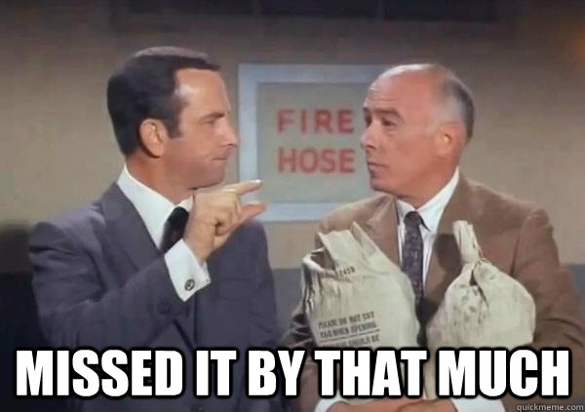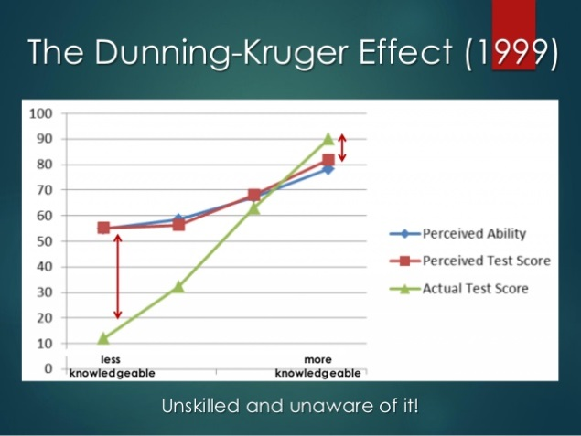

**Chump**

**Figure 7**

Note in figure 7 above, the “Chump” area in the graphical presentation Kruger and Dunning research. This area is where the “perceived ability exceeds the actual tested ability. This area shows the extent of self-deception concerning competency. This is the area where the less competent technician, who is less capable of improvising or deviating from procedures safely, would over rate their ability to do so and be more likely to make an error of judgment when deviating from procedures. They would be duped by the environment in which deviation from procedures is normal and allowable. In the non-chump range, where actual ability exceeds perceived ability, the most capable technicians would underestimate their judgment when deviating from procedures and they could be trusted not to make errors in judgment when doing so. [22]

As the Behavioral Psychologist pointed out in the British Airways Flight BA 5390 report, it is a questionable practice to leave the safety of aircraft entirely to individual judgments concerning which maintenance standards and practices are used or the extent to which procedure or work instructions are followed.

When the head of the aircraft mechanic school I attended, Mr. Malara, died 20 years ago, I dealt with the grief by writing an article published in Aviation Maintenance Technician magazine titled Professional Rider. In it, I identified what he taught us professionalism in aviation maintenance requires. Professional is what professional does.

See how intentional failure to follow procedures does not fit the definition of professionalism Mr. Malara taught: [23]

1. Only black and white
2. One way and one way only
3. Think ahead
4. Double check everything
5. Ask when you are not sure
6. Be responsible for your actions
7. Do not assume anything!

When making an unintentional error when following procedures, the unexpected consequence can accurately be called an accident. But, when intentionally deviating from procedures, the unintended consequence strains the definition of the term accident. Accident is usually defined as something unfortunate that happens unexpectedly and unintentionally resulting in damage or injury; an event that happens by chance or that is without apparent or deliberate cause. The term accident has the connotation that nothing could have been done to prevent it. In the accidents we have looked at, following procedures would have prevented them. That is how Mr. Malara would have viewed them. [24, 25 & 26]

**Conclusion and Recommendation**

The accidents reviewed above occurred fifteen to thirty years ago. Is there a current risk of the same causes of failure to follow procedures and the intent of the regulatory requirements for Required Inspection not being met?

According to the press there is. In the summer of 2015, in the southwestern United States, a 158 seat passenger aircraft experienced an uncommanded rotation at 138 knots during takeoff roll. Full forward control input did not arrest the rotation and the takeoff was aborted without incident. The malfunction was caused by an unsecured bolt, which allowed the device that controls the elevators to become disconnected. It fell off and became jammed holding the elevator in one position. More than 200 flights were conducted since the major maintenance visit in which technicians failed to install a cotter pin in the nut connecting the input rod to an elevator hydraulic actuator. The maintenance performed should have been RII but did not get identified as such. [27, 28, 29 & 30]

From the seven accidents reviewed above, I hope that the reader can conclude that in maintenance, the devil is not in the details. **The danger is in the normalized deviation of not following procedures combined with, and the failure to meet the intent of RII regulations.** The expression “couldn't see the forest for the trees” is used of someone who is too involved in the details of a problem to look at the situation as a whole. In maintenance caused accidents, each tree’s (accident’s) specific failure to follow procedures and its falling short of the intent of RII regulations, has not been expanded to see the blight in large areas of the forest itself.

The theme of ISASI’s 2017 annual conference was **"Investigations - Do They Really Make a Difference?”** Well, investigation is what investigation does!

**If investigation of future maintenance caused accidents provides safety recommendations to correct the normalized deviation of failure to follow procedures in maintenance and to make RII regulation more effective, then the answer will be YES!**

**The views expressed in this paper do not necessarily represent the views of the United States (U.S), the U.S. Department of Transportation (DOT), the Federal Aviation Administration, or any other Federal agency.**

**References**

1. L. Pete Kelley. 2016. (working paper) “Accident Causation Theory and Overlooked or Under-Addressed Maintenance Factors.” *ResearchGate.* <https://www.researchgate.net/publication/304627695_Accident_Causation_Theory_and_Overlooked_or_Under-Addressed_Maintenance_Factors>
2. Kahneman, Daniel. 2011. *Thinking, Fast and Slow*. Farrar, Straus and Giroux/New York. p. 277.
3. Thomas Kuhn. 1962. *The Structure of Scientific Revolution*. University of Chicago Press.
4. Dekker, Sidney W. A. 2011. "Systems Thinking 1.0 and Systems Thinking 2.0: Complexity science and a new conception of "cause." *Aviation in Focus*. Pontificia Universidade Catolica do Rio Grande do Sul. 2 (2): 21–39. Retrieved November 13, 2013.
5. http://www.boeing.com/resources/boeingdotcom/company/about_bca/pdf/statsum.pdf
6. H W Heinrich. 1931. *Industrial Accident Prevention: A Scientific Approach*. New York: McGraw-Hill.
7. 1993. “Accident Prevention Strategies: Removing Links in the Accident Chain.” *Boeing Commercial Airplane Group, Airplane Safety Engineering*.
8. Rankin, B; and Allen, J. 1996. “Boeing Introduces MEDA - Maintenance Error Decision Aid.” *Airliner Magazine*, April-June. pp. 20-27.
9. 1989. Accident Report. “Delta Flight 1141 on August 31,1988.” *NTSB.* Washington DC. NTSB/AAR-89/04.
10. Hobbs, Alan. 2008. “An Overview of Human Factors in Aviation Maintenance.” AR-2008-055, *Australian Transportation Safety Bureau, ATSB Transport Safety Report,* Aviation Research and Analysis Report, Final. December 2008.
11. Vaughan, Diane. 1996. *The Challenger Launch Decision: Risky Technology, Culture, and Deviance at NASA*. University of Chicago Press, Chicago.
12. L. Pete Kelley. 2016. (working paper) “General and Specific Realities of Aircraft Maintenance.” *ResearchGate.* <https://www.researchgate.net/publication/304627916_General_and_Specific_Realities_of_Aircraft_Maintenance>
13. 2004. *National Transportation Safety Board*. Washington, DC 20594. Brief of Accident NYC03MA183. 08/31/2004.
14. 2004. Aircraft Maintenance and Records Group Factual Report for accident NYC03MA183. *NTSB*. Washington DC. March 16, 2004.
15. 2004. Accident Report. “Air Midwest Flight 5481 on January 8, 2003.” *NTSB.* Washington DC. NTSB/AAR-04/01 and Docket for DCA03MA0221.
16. 2002. Accident Report. “Alaska Airlines Flight 261 on January 31, 2000.” *NTSB*. Washington DC. NTSB/AAR-02/01.
17. 1997. Accident Report. “ValuJet Airlines Flight 592 on May 11, 1996.” *NTSB*. Washington DC. NTSB/AAR-97/06.
18. 1998. Accident Report. “Delta Air Lines Flight 1288 on July 6, 1996” *NTSB*. Washington DC. NTSB/AAR-98/01.
19. 1992. Accident Report. “Continental Express Flight 2574 on September 11, 1991” *NTSB.* Washington DC. NTSB/AAR-92/04.
20. 1992. Accident Report. “British Airways Plc Flight BA 5390 on June 10, 1990” *Department of Transport, Air Accidents Investigation Branch.* Aircraft Accident Report 1/92.
21. 2005. “This is your captain screaming.” *THE SYDNEY MORNING HERALD*, February 5, 2005. <http://www.smh.com.au/news/World/This-is-your-captain-screaming/2005/02/04/1107476802601.html>

1. Kruger, Justin and Dunning, David. 1999. “Unskilled and Unaware of It: How Difficulties in Recognizing One’s Own In competence Lead to Inflated Self-Assessments.” *Journal of Personality and Social Psychology*, Vol. 77, No. 6, pp. 1121-1134.

<http://psych.colorado.edu/~vanboven/teaching/p7536_heurbias/p7536_readings/kruger_dunning.pdf>

<https://www.google.com/search?q=unskilled+and+unaware+of+it&source=lnms&tbm=isch&sa=X&sqi=2&ved=0ahUKEwjhm7q3qtnUAhVG0oMKHfAFB4IQ_AUIBygC&biw=1920&bih=900&dpr=1#imgrc=cJA9eI9HIRjitM:&spf=1498405255058>

1. L. Pete Kelley. 1998. “Professional Rider.” *Aviation Maintenance Technology Magazine*. April Issue.
2. <https://www.google.com/?gws_rd=ssl#q=definition+of+accident&spf=1498401268667>
3. <https://www.washingtonpost.com/news/wonk/wp/2015/08/24/when-a-car-crash-isnt-an-accident-and-why-the-difference-matters/?utm_term=.e23d4fd54edf>
4. <http://www.motherjones.com/kevin-drum/2015/08/crash-vs-accident-doesnt-seem-it-matters-very-much/>
5. <http://www.tampabay.com/news/business/airlines/allegiant-vegas-flight-nearly-lost-control/2243190>
6. <http://www.bloomberg.com/news/articles/2015-10-28/unsecured-jet-bolts-under-heightened-faa-scrutiny-at-allegiant>
7. <https://www.flightglobal.com/news/articles/faa-defends-response-to-allegiant-2015-rudder-jam-437238/>
8. <http://www.ktnv.com/news/contact-13/allegiant-aborts-takeoff-after-critical-flight-system-fails>

Note, the title of this paper, using syntactic ambiguity, was derived from the book Eats, Shoots & Leaves: The Zero Tolerance Approach to Punctuation Lynne Truss, Profile Books: UK 2003 and it combines Forrest Gump from the 1994 American comedy-drama film based on the 1986 novel of the same name and the saying “can’t see the forest for the trees.